Australia’s Landforms

Ocean | 500 | Granite | Sediment | Basins | Sea | Four | Largest
Volcanoes | Millions | Population | Forces | Climate | Divided | Carpentaria | Eastern

The landforms of Australia can be ____________ into________ major regions. The Great Western Plateau is the___________ region. It takes up two thirds of the Australian continent and is made of very hard _____________ rock. The rock has been worn away to form flat tablelands at about _______metres above sea level. The Central Lowlands extend from the Gulf of _____________to the mouth of the Murray River. It mainly consists of sedimentary rock. This rock was formed when layers of sand and silt were left behind after the area was covered by the _________, and over time, the layers of ____________ have become rock. Because the region is mostly at about sea level, huge drainage ____________ collect the water from the higher land around it, and direct it to the _______. The third landform region is the Great Eastern Highlands. This highland region covers the entire length of the __________ edge of Australia. Its mountains were formed _____________of years ago when sedimentary rock was folded, faulted and upset by ______________. The coastal lowlands include most of the narrow, low-lying strip around the edge of Australia. The vast majority of Australia’s _____________ live in this region because of its mild __________and fertile soil. The four regions have very different shapes because of the ____________ that created them.

In the table below, record the information from the paragraph in note form in the appropriate columns:
TITLE: _________________________________________________________

The Great Western Plateau | The Central Lowlands | The Great Eastern Highlands | The Costal Lowlands

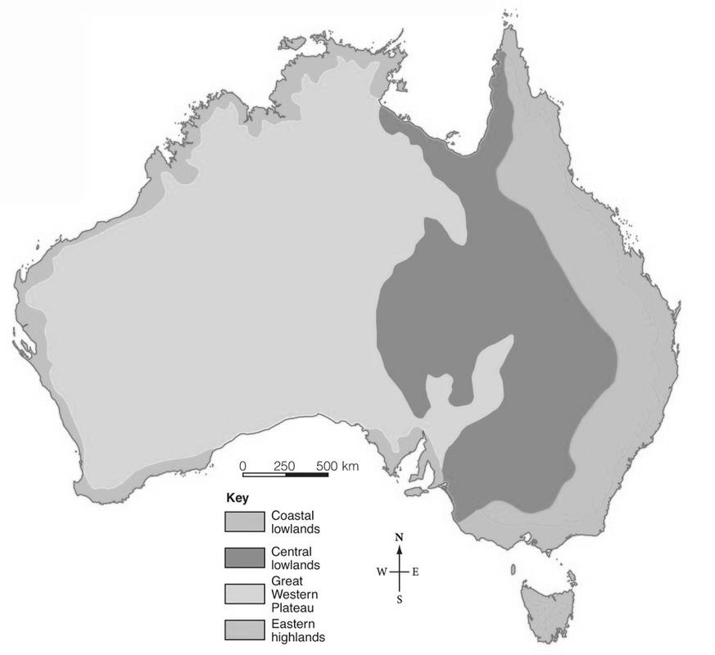
INSTRUCTIONS
1) On the map, colour the;
- Coastal Lowlands: BLUE
- Central Lowlands: GREEN
- Great Western Plateau: YELLOW
- Eastern Highlands: RED

USING AN ATLAS
2) Label the following cities on the map:
- Sydney
- Perth
- Adelaide
- Darwin
- Brisbane
- Melbourne
- Hobart

3) Label the following landforms on the map:
- Uluru
- Mount Kosciusko
- Wave Rock
- The Twelve Apostles
- Lake Argyle
- The Simpson Desert

4) Make a list of 10 other landforms that you know of in Australia.

